**Test Case 11**

**System:** Bench

**Description:** Test that the user is able to receive a notification when there is a new incoming chat.

**Severity:** 4

**Instructions**

**Test 1**

1. Start the Bench application.
2. Click the button “Login” on the navigation bar.
3. Enter the email “user3@gmail.com” into the text field labeled “Email address” to login as user3.
4. Enter the password “12345678” into the field labeled “Password”.
5. Click the button “Login” below the field.
6. After the screen has loaded, click on the button “Chat” on the navigation bar.
7. Click the existing chat panel labeled “TEAM 23”.
8. Send a message from user3 to TEAM 23 by entering a message in the input field and clicking the send button.
9. Open a new tab, and login TEAM 23’s gmail mailbox with address “[team23project@gmail.com](mailto:team23project@gmail.com)” and password “12345678”.
10. Check the gmail inbox.

**Expected Result:** The gmail of TEAM 23 should have received an incoming email notification that says the user user3 has sent you a message.

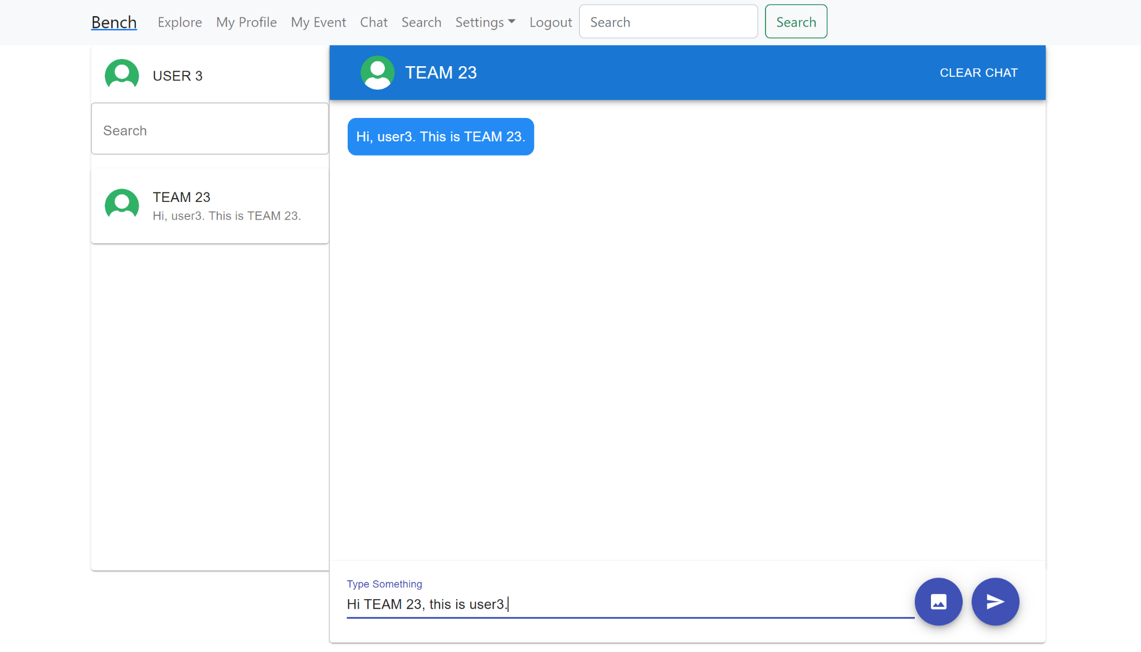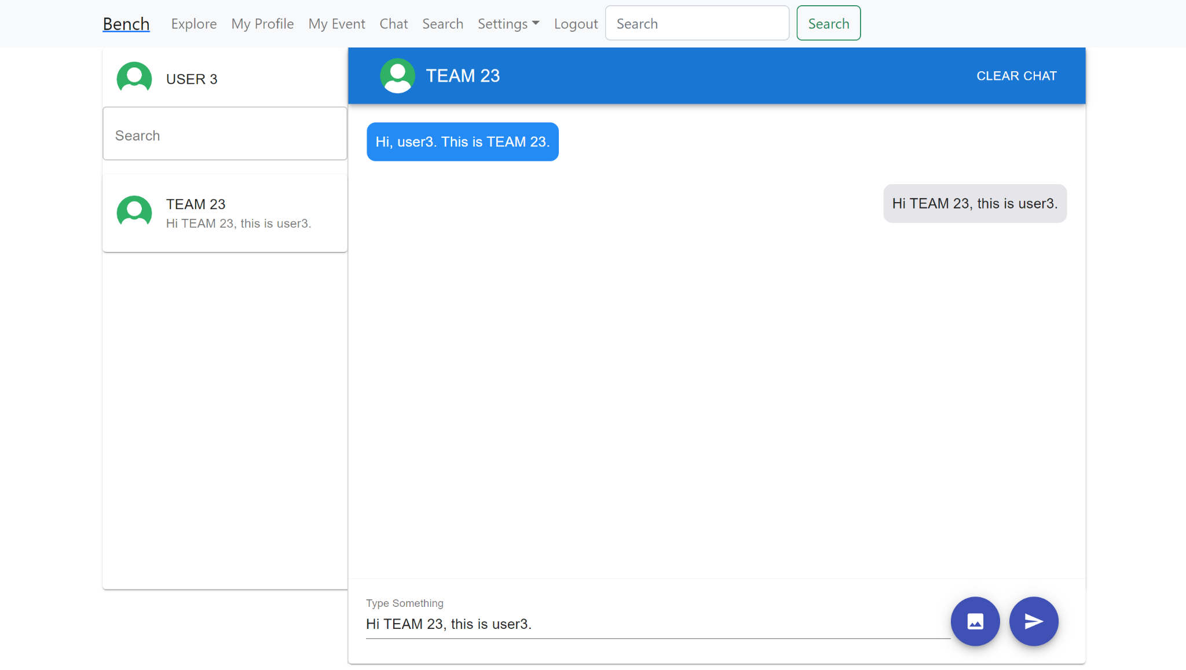

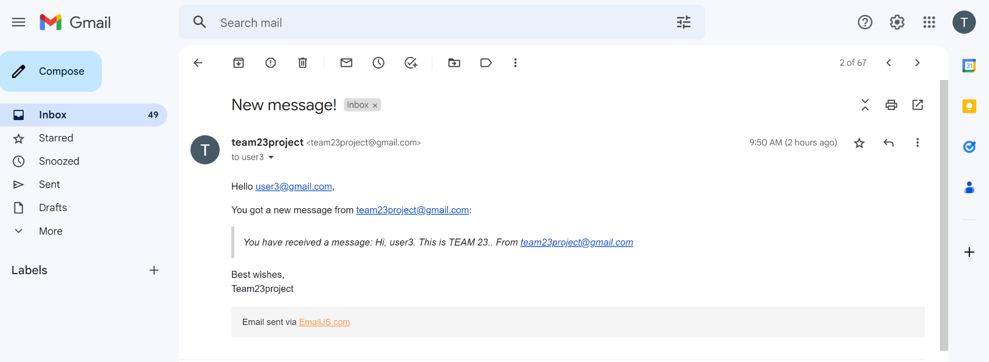

**Test 2**

1. Start the Bench application.
2. Click the button “Login” on the navigation bar.
3. Enter the email “user3@gmail.com” into the text field labeled “Email address” to login as user3.
4. Enter the password “12345678” into the field labeled “Password”.
5. Click the button “Login” below the field.
6. After the screen has loaded, click on the button “Chat” on the navigation bar.
7. Click the existing chat panel labeled “TEAM 23”.
8. Send a message from user3 to TEAM 23 by entering a message in the input field and clicking the send button.
9. Open a new tab, and login TEAM 23’s gmail mailbox with address “[team23project@gmail.com](mailto:team23project@gmail.com)” and password “12345678”.
10. Check the gmail inbox. The gmail of TEAM 23 should have received an incoming email notification that says the user user3 has sent you a message.
11. Observe the incoming email notification.

**Expected Result:** the sender of this incoming email notification should be the administrator, “team23project@gmail.com”.



**Test 3**

1. Start the Bench application.
2. Click the button “Login” on the navigation bar.
3. Enter the email “user3@gmail.com” into the text field labeled “Email address” to login as user3.
4. Enter the password “12345678” into the field labeled “Password”.
5. Click the button “Login” below the field.
6. After the screen has loaded, click on the button “Chat” on the navigation bar.
7. Click the existing chat panel labeled “TEAM 23”.
8. Send a message from user3 to TEAM 23 by entering a message in the input field and clicking the send button.
9. Open a new tab, and login TEAM 23’s gmail mailbox with address “[team23project@gmail.com](mailto:team23project@gmail.com)” and password “12345678”.
10. Check the gmail inbox. The gmail of TEAM 23 should have received an incoming email notification that says the user user3 has sent you a message.
11. Observe the incoming email notification.

**Expected Result:** the incoming email notification should include the details of the incoming message, which is the sender, “user3”, and the content of the message.

